Knees to Elbows

V-Sit

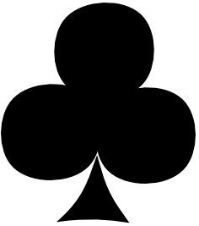

Curl Ups

Mountain Climbers